CO2
SIMULATION EXPERIMENT – 5
Electromagnetic Simulation and S-Parameter Characterization of a Microwave Directional Coupler and Two-Way Power Divider.

A. Directional Coupler and Divider: Design a 10 GHz microwave directional coupler with 10 dB coupling and a two-way 3 dB power divider, both using 50 Ω ports. Simulate from 8–12 GHz. At 10 GHz obtain S11, S21, S31 and the isolated-port response. Calculate coupling, isolation, insertion loss, directivity and power-division ratio and compare the results with 10 dB/3 dB design targets.
B. Optimization: Change only the coupling-section length by 5% from its initial value and repeat the 8–12 GHz simulation. Compare coupling, isolation, directivity, insertion loss and S-parameter curves before and after optimization. Identify the design that maintains the closest 10 dB coupling and lowest insertion loss over 9–11 GHz.
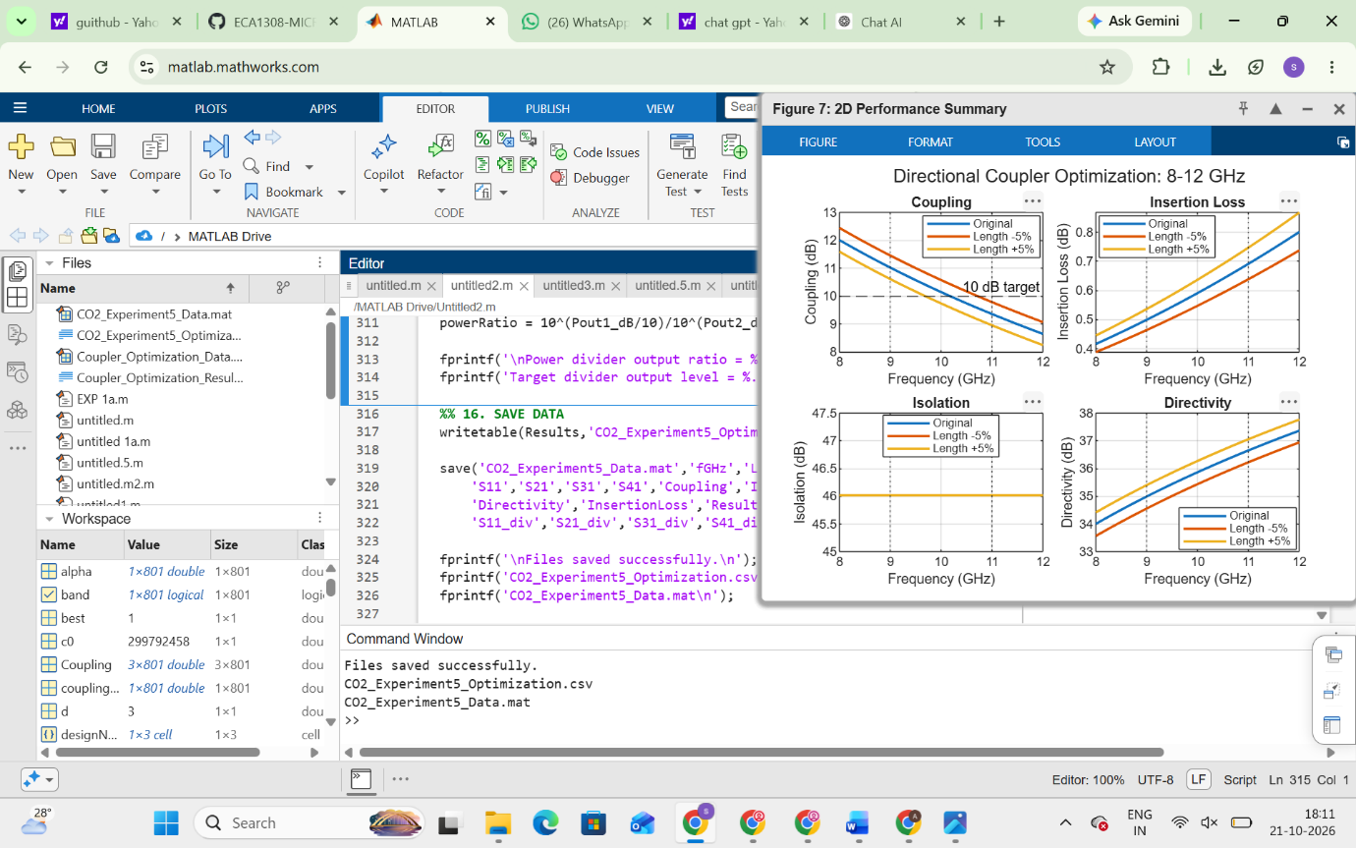
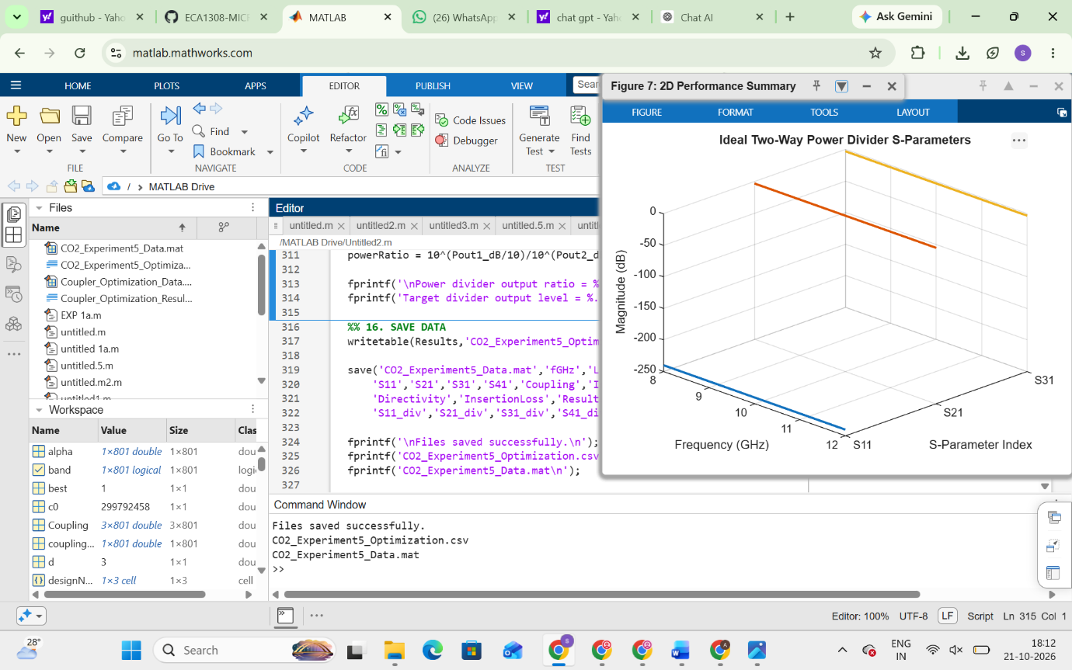
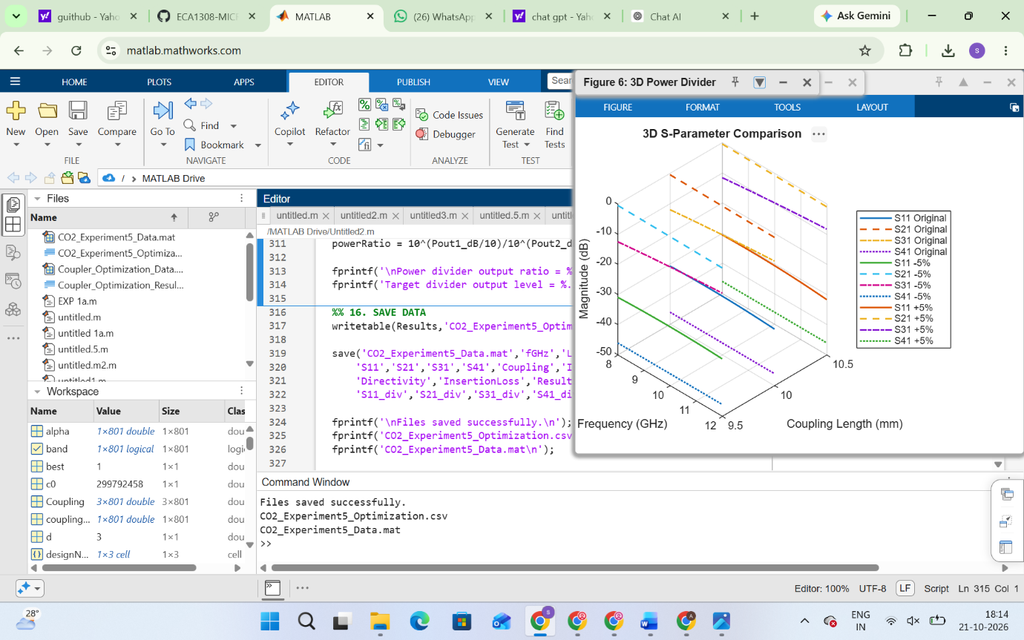
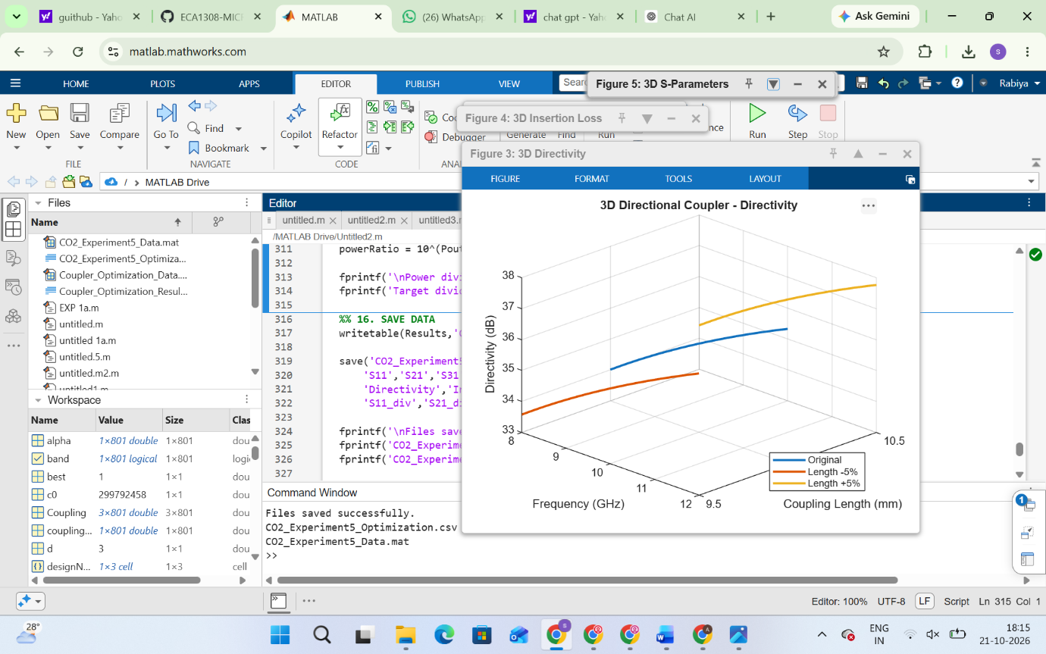

SIMULATION EXPERIMENT – 6
Simulation-Based Investigation of Microwave Semiconductor Devices and Frequency-Conversion Characteristics of a Microwave Mixer

Objectives of this Experiment:
1. To develop simulation models representing the operating characteristics of selected microwave semiconductor devices.
2. To analyze the electrical characteristics and frequency-dependent behavior of Gunn, Schottky or PIN diode-based microwave structures.
3. To simulate frequency conversion in a microwave mixer and identify the generated frequency components.
4. To evaluate conversion characteristics and identify suitable operating conditions for microwave applications.
Experimental Procedure
A. Mixer Frequency Conversion: Set fRF = 10 GHz, fLO = 9.5 GHz, PRF = −10 dBm and PLO = +7

dBm with a 50 Ω IF load. Obtain the output spectrum. Calculate the theoretical IF frequency |10−9.5| =
0.5 GHz and sum frequency 19.5 GHz. Identify the simulated components and calculate the percentage frequency deviation.
B. Conversion Loss: Using the same mixer, record the IF output power at 0.5 GHz. Calculate conversion loss CL = PRF − PIF and compare it with the expected passive-mixer range of approximately 6–10 dB. Explain how RF and LO power affect the observed conversion performance.
